FlexNet Manager Suite
Data Import Web Portal

Last updated July 23, 2018

This document contains proprietary trade secrets of Flexera Software LLC. Receipt or possession does not convey any right to reproduce, disclose its content, or to manufacture, use, or sell anything that it may describe. Reproduction, disclosure or use without specific authorization of Flexera Software is strictly forbidden.
Contents
1 Introduction 3
2 Use 3
3 Installation and Configuration 4
4 Adapter Development Guidance 5
4.1 Adapter Registration 6
4.2 Adapter XML Requirements 8
4.3 Connection String 8
4.4 Adapter Best Practices 9
4.4.1 Source Record Identification and Tracing 9
4.4.2 Source Queries 10
4.4.3 Object Names 10
4.4.4 Import Signatures 11
4.4.5 Lookup Objects for Optional Properties 11
4.4.6 Data Validation 12
4.5 Sample Adapters 21
5 Troubleshooting 21
5.1 Logging 21
5.2 State 21
5.3 Manual Execution 21
6 Limitations, Restrictions and Known Problems 22
7 Future Enhancements 23
8 Support and Feedback 23

Introduction
This document describes the Data Import Web Portal component which can be used to support uploading data files (spreadsheets, text or XML files) to a web page in the FlexNet Manager Suite UI, and importing those files using an adapter. It can be used in situations where end users require an interface for performing bulk imports of data into FlexNet Manager Suite using custom file formats or adapters, and where those end users do not have access or skills to directly use adapters running on beacons.
The Data Import Web Portal is contributed and unsupported content. It may or may not suit your needs. There is no guarantee that the kind of capabilities exposed here will continue to be possible in any future FlexNet Manager Suite release. If these constraints are unacceptable for your scenario, do not use the Data Import Web Portal.

Use
Once the Data Import Web Portal has been installed and configured (see the Installation and Configuration section later in this document), it can be accessed and used as follows:
- Use a web browser to browse to FlexNet Manager Suite.
- Navigate through the system menu ( in the top right corner) > Data Inputs. The Data Inputs page opens.
- Select the Upload Data tab.
- Select a type of data file to be uploaded where prompted.
- A link to download a template file for the upload data may be provided (depending on the configuration of the data file type selected).
- Browse to and select a file containing data to be uploaded in the format required by the data file type selected and click the import button to upload and queue the file for importing.
- Monitor the status of the uploaded file in the Previous Uploads section of the page.
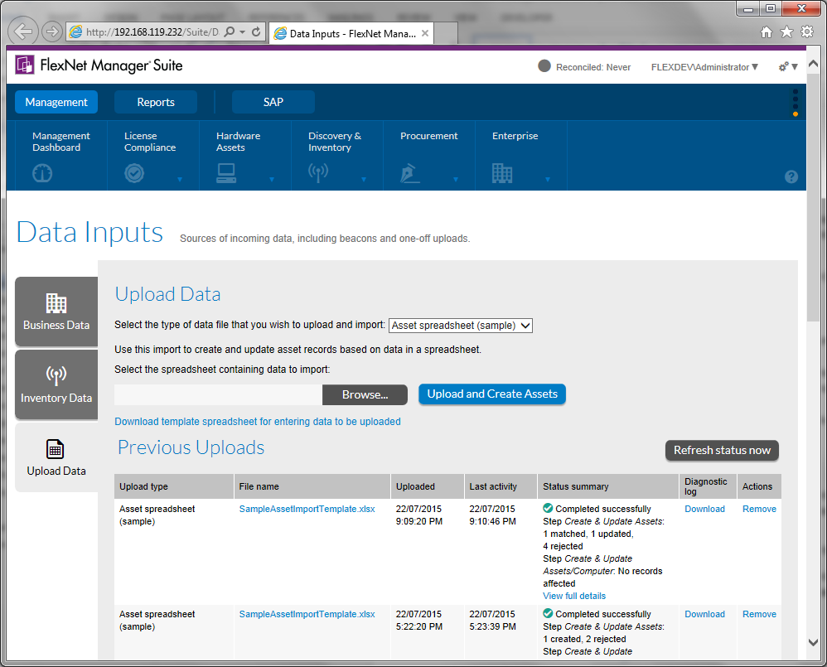
When a file is uploaded, it is placed in a processing queue to be processed in order of upload. The status of uploads under the Previous Uploads section of the web page refreshes automatically on a regular basis to show status.
Details of uploads are automatically deleted from the system according to the Number of days to keep activity logs setting configured in the System Settings > Inventory page of the FlexNet Manager Suite web interface.
Operators must have the following access rights to FlexNet Manager Suite to access and use the Data Import Web Portal:
- Administration > Import from database sources and enterprise group files
- Administration > Configure FlexNet Manager Platform properties
Operators who also have the Administration > Troubleshooting: advanced access and log downloads access right can see and interact with all upload tasks performed by themselves or any other users. Operators without this right can only see and interact with their own upload tasks.

Installation and Configuration
Install the Data Import Web Portal by executing the following commands as a user in the FlexNet Administrators security group:
- Download and install the Microsoft Access Database Engine 2010 Redistributable on the batch server to enable importing of Excel spreadsheet data into FlexNet Manager Suite using business adapters (use the AccessDatabaseEngine.exe installer file).

- On the batch server, execute the following commands to configure database settings and a scheduled task named FlexNet Manager Platform\Local\Process Data Import Web Portal uploads to watch for and process uploaded data:

.\flexadmin.ps1 ConfigureDataImportWebPortal
.\flexadmin.ps1 ConfigureDataImportWebPortalScheduledTask

- If the web server is running on a different computer from the batch server, execute the following command to configure the web portal on the web server:

.\flexadmin.ps1 ConfigureDataImportWebPortal

Tip: As a best practice, put arrangements in place to ensure nobody is using the data import web portal while this command is executed. There is a small chance that strange behavior may occur if the data import web portal configuration is being updated at the same time that somebody is using the portal.

- If the Data Import Web Portal has previously been configured on the web server, and the only change being deployed is to add a new adapter to the portal, then the FlexNet Manager Platform IIS application pool may need to be restarted in order for the new adapter to be displayed in the web user interface.

- Navigate through the FlexNet Manager Suite web interface system menu ( in the top right corner) > Data Inputs. The Data Inputs page opens. Ensure the Upload Data tab appears and can be selected without any indication of an error occurring.

Adapter Development Guidance
Files for each adapter to be exposed via the Data Import Web Portal must be placed in a subdirectory under the Adapters directory. There are typically 3 files in each adapter directory:
- MGSBI.xml: Business adapter (MGSBI) configuration file defining how to import data into FlexNet Manager Suite.
- AdapterRegistration.xml: Configuration file for the Data Import Web Portal detailing how to display details about and execute the adapter.
- A template data file for end users to download and fill in for subsequent uploading to the Data Import Web Portal.
Whenever a change to files in this directory need to be deployed to become active, the following command should be executed as a user in the FlexNet Administrators security group on the web server:
.\flexadmin.ps1 InstallDataImportWebPortalAdapters
When a new adapter is first added (installed) to the portal, then the FlexNet Manager Platform IIS application pool may need to be restarted in order for the new adapter to be displayed in the web user interface.

Adapter Registration
A file named AdapterRegistration.xml should be placed alongside the adapter configuration XML file. This file is used by the Data Import Web Portal to understand how to display details about and execute the adapter.
A sample annotated AdapterRegistration.xml file illustrating the expected structure of this file follows:
<?xml version="1.0" encoding="utf-8"?>
<!--
This configuration file contains details to register the
business adapter in this folder with the Data Import Web
Portal.
-->
<BusinessAdapterRegistration>
<!--
Text to be displayed in drop down list for selecting
which data file type to import
-->
<DisplayName>Asset spreadsheet (sample)</DisplayName>
<!--
Additional descriptive information about this data file
type to be displayed when it is selected.
Default if not specified: Blank (no description)
-->
<DisplayDescription>
Use this import to create and update asset records
based on data in a spreadsheet.
</DisplayDescription>
<!--
Text to be displayed to prompt user to select a file
to be uploaded.
Default if not specified:
"Select the file to upload and import:"
-->
<SelectFileLabel>
Select the asset spreadsheet containing data to import:
</SelectFileLabel>
<!--
Expected extension of files that are uploaded to be
imported by this adapter (typically "xls", "xlsx",
"csv" or "xml")
-->
<UploadFileType>xlsx</UploadFileType>
<!--
Text to display on the "Upload" button to upload
and queue a file for importing.
Default if not specified: "Upload"
-->
<ImportButtonText>Upload and Create Assets</ImportButtonText>
<!--
Text to display in a link to download a template
file with the correct structure to be populated for
importing via this adapter.
Default if not specified: "Download template"
-->
<TemplateFileHyperlinkDescription>
Download template asset spreadsheet for entering
data to be uploaded
</TemplateFileHyperlinkDescription>
<!--
Name of the template file. Leave this blank if there
is no template file. This file must exist in the same
directory as the AdapterRegistration.xml file.
-->
<TemplateFileName>
SampleAssetImportTemplate.xlsx
</TemplateFileName>
<!--
Business adapter (MGSBI) config file containing the
adapter definition to be executed to process uploaded
files.
-->
<ConfigFile>MGSBI.xml</ConfigFile>
<!-- Name of the import in ConfigFile to be executed. -->
<ImportName>SampleAssetImport</ImportName>
</BusinessAdapterRegistration>

Adapter XML Requirements
The case of XML content in the adapter configuration XML file is significant for the Data Import Web Portal. For example, the case of the following elements and attributes must be specified as shown here:
- <Import ConnectionString=...>
- <Log>
Adapters configured using the Business Adapter Studio will meet these constraints.
<Log> items can be configured in an adapter, but any such items are removed from the adapter configuration XML file when the adapter is executed by the Data Import Web Portal and replaced by other log items required by the Data Import Web Portal.

Connection String
When configuring adapters to import data from spreadsheet or text (CSV) files, the connection string value configured in the adapter is expected to contain the text "Data Source=".
If the adapter is developed using the Business Adapter Studio, this will happen automatically. If the adapter XML is edited or prepared by hand, the connection string in the <Import> element should look like the following:
<Import ... ConnectionString="Provider=...;Data Source=AssetSpreadsheet.xlsx;">
When the adapter is executed, the path to the source data file specified in the connection string will be replaced with the actual path of the data file to be imported.
An implication of this requirement is that the Encrypt Connection Information setting on the import must not be checked:
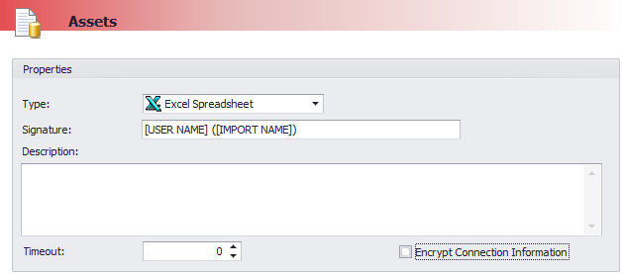
The requirements described in this section do not apply when importing data from XML files. In this case the Data Import Web Portal uses a connection string that simply contains the full path to the file to be imported, and so the connection string you specify in the adapter is completely overwritten.

Adapter Best Practices

Source Record Identification and Tracing
It is good practice to specify a SQL expression in the Column(s) for tracing field on the import object in the Business Adapter Studio. The expression should evaluate to a human-readable value (based on data read from the data source) which identifies the source record being imported. These values will be displayed by the Data Import Web Portal to the operator when identifying and displaying information about specific rows in the source data.
It is also good practice to enable tracing for all the following options so that operators who perform imports can drill down to see exactly how each imported record was treated:
- Created records
- Deleted records
- Updated records
- Rejected records
For example, if an adapter logically identifies source records based on serial number, an expression such as shown in the following screenshot may be appropriate:
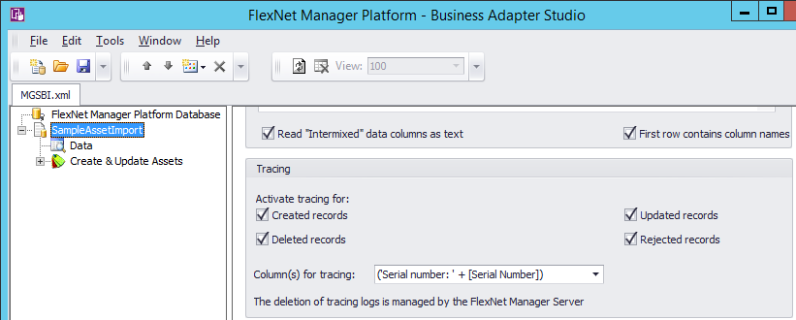
Tip: Some versions of the Business Adapter Studio will remove any leading single quote (') characters in the Column(s) for tracing property. To avoid this problem, surround the expression with parentheses as illustrated in the screenshot above.
If editing an adapter XML file manually, this value can be specified in the TraceFields attribute of the <Import> object:
<Import ... TraceFields="('Serial number: ' + [Serial Number])">

Source Queries
The query executed to obtain data from the source data file should bring in all rows from the file so that record numbers returned by the query correspond to row numbers in the data file.
The Data Import Web Portal provides feedback which identifies rows by number, and if the source query returns a different set of rows from what is represented in the source data file then these row numbers will not be meaningful to operators.

Object Names
Give meaningful names to import objects in adapters. These names will be displayed to operators using the Data Import Web Portal as “import steps”. A helpful convention is to use names of the form “verb noun” describing the action and object being operated on. Some examples of good object names are:
- Create & Update Assets
- Lookup Assigned Users
The default names assigned to import objects can be changed in the Business Adapter Studio by right-clicking on the object and selecting Rename:
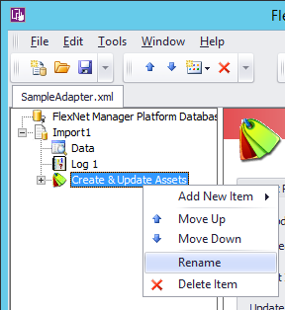
If editing an adapter XML file manually, object names value can be specified in the Name attribute of each <Object> object:
<Object... Name="Create &amp; Update Assets">
Tip: Object names are strictly limited to 50 characters in length. Be aware that the Business Adapter adds on additional characters in some situations (for example, when importing asset records) to your object name, so avoid using names longer than 40 characters.

Import Signatures
It is good practice to explicitly configure the import Signature property to avoid using the import name in the signature. For example:
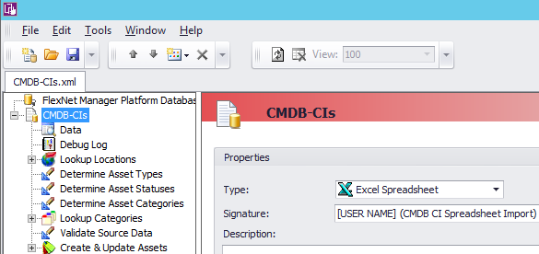
The default import signature is [USER NAME] ([IMPORT NAME]). When data is imported by the Data Import Web Portal, a unique import name is assigned to each import, so using the import name in the signature is not ideal.
A good practice is therefore to replace the [IMPORT NAME] part of the default import signature with some description of the import which will make sense to end users when they view this information in FlexNet Manager Suite. The import signature is visible in the Created by and Last updated by fields on the History tab of many record types in the FlexNet Manager Suite web interface.

Lookup Objects for Optional Properties
A common pattern in adapters is to use an object to search for (not create or update) existing records, where the source field that is used for the search is optional. For example, an adapter may search for a User record which will then be used to set the Assigned User property on an Asset record.
For example, this may be configured in an adapter similarly to the following screenshot:
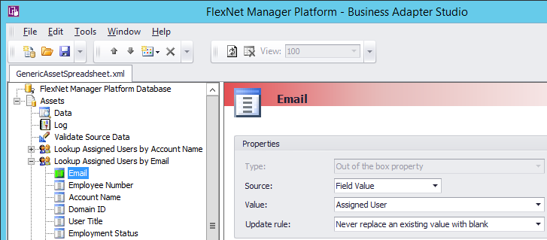
If this model is used in a situation where the source field used for doing the search may be blank (for example, if the Assigned User field in the source data file is blank in the above scenario), built-in behavior in the business adapter component can generate unhelpful and confusing messages such as the following indicating that the record has been rejected, and the import will be reported as being completed with a failure:
Null or empty value was found in criteria field [fieldname];
A strategy for avoiding these types of misleading rejection messages and the consequent indication of the import failing is to use a custom SQL query to force blank source data values to a non-blank value that will never be found. For example:
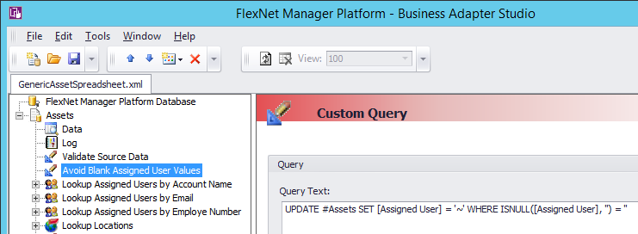

Data Validation
This section describes some facilities that the Data Import Web Portal provides to assist with validation of data prior to it being imported.
The process of reliably importing good quality data can be greatly helped by validating the syntactic and semantic integrity of source data and reporting clear and precise validation failure messages to the operator. Validation of data in business adapters requires the use of custom SQL query objects in the adapter, with carefully crafted SQL statements to identify and reject bad data.
An example of a custom SQL query performing validation is shown in the following screenshot:
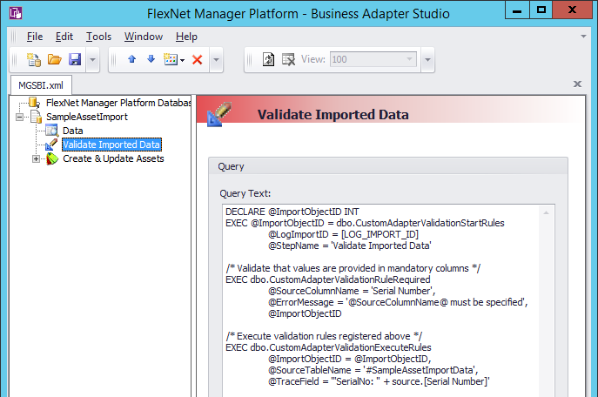
When source data validation is performed as described here, details of rows rejected from being imported because of a validation failure are shown to operators in the Data Import Web Portal interface.
Tip: All the lines of SQL script in a custom SQL object in an adapter will be collapsed down to a single line as part of the processing of the adapter. Generally this does not cause a problem as it does not change the SQL script. One exception to this is that the use of “--” comments in the script will not work as the remainder of the SQL script will be ignored after the first such comment. To avoid problems from this, always use /* … */ style comments in SQL script within custom SQL objects in adapters.

SQL Stored Procedures for Validation
The Data Import Web Portal provides the following SQL stored procedures to help with validation.

dbo.CustomAdapterValidationStartRules
Call this procedure at the top of a custom SQL object in the adapter to start processing a set of validation rules. Subsequent statements in the custom SQL object will detail the specific validation to be performed.
Parameters:
- @LogImportID INT: This parameter identifies the current import that is running. It is typically specified using the special text “[LOG_IMPORT_ID]”. The business adapter (MGSBI.exe) finds and replaces this text with the import identifier when the adapter runs.

- @StepName NVARCHAR(50): This parameter is a human-readable string identifying the import processing step. It should typically be the same value as the custom SQL object name.
Returns:
- An INT value which will be used to identify the validation step when calling other validation-related stored procedures.
Example:
DECLARE @ImportObjectID INT
EXEC @ImportObjectID = dbo.CustomAdapterValidationStartRules
@LogImportID = [LOG_IMPORT_ID],
@StepName = 'Validate Imported Data'

dbo.CustomAdapterValidationRegisterRule
This procedure is used to register a validation “rule” to be executed over the source data. Any records identified by the rule are invalid.
Parameters:
- @ImportObjectID INT: A value returned from a previous execution of the dbo.CustomAdapterValidationStartRules stored procedure identifying the current import validation step being executed.

- @ValidationRule NVARCHAR(MAX): A SQL expression which will evaluate to true for any record in the source data that is considered invalid according to the rule being registered. The expression should refer to the source data table using the fixed name “source”.

This expression will be inserted into the WHERE clause of dynamically executed SQL statements to identify invalid records. The statements are generally constructed as follows:
SELECT /* ... */
FROM #SourceDataTable AS source
WHERE (/* the @ValidationRule expression goes here */)

The @ValidationRule may contain the following special strings which will be dynamically replaced when the rule is executed:
  - “@SourceColumn1Name@” will be replaced by the value of the @SourceColumn1Name parameter. This is helpful in situations where multiple rules are to be registered with the same validation rule expression except for identification of the source column name.
  - Similarly, “@SourceColumn2Name@” will be replaced by the value of the @SourceColumn2Name parameter.

- @ErrorMessage NVARCHAR(3000): The validation error message to be reported in relation to any record(s) which this rule identifies as being invalid.

The @ErrorMessage may contain the following special strings which will be dynamically replaced when the rule is executed:
  - “@SourceColumn1Value@” will be replaced by the value held in the column named by the @SourceColumn1Name parameter (see below). This is helpful to include details of the specific value which failed to be validated in the message.
  - “@SourceColumn1Name@” will be replaced by the value of the @SourceColumn1Name parameter. This is helpful in situations where multiple rules are to be registered with the same error message except for identification of the source column name.
  - “@SourceColumn2Value@” and “@SourceColumn2Name@” will be similarly replaced based on the @SourceColumn2Name parameter.

- @SourceColumn1Name NVARCHAR(256): This parameter names a column in the data source being validated. This parameter does not have to be specified if neither the @ErrorMessage nor the @ValidationRule parameters contain the special text “@SourceColumn1Name@” or “@SourceColumn1Value@”.

- @SourceColumn2Name NVARCHAR(256): Similar to the @SourceColumn1Name parameter, but allows for a 2nd column to be referenced in the validation.

- @IsGlobalRule BIT = 0: Specifies whether (0) this validation rule applies to individual rows of data (checking each row individually), or whether (1) this validation rule does not apply to individual rows of data but instead applies globally.

If @IsGlobalRule is 1 then the @ValidationRule expression must not refer to the source table alias. If the expression evaluates to false then all data source rows are rejected and not imported.
Example:
The following example validates that device_id values in the source data are unique, only allowing the first row with a non-unique value through as valid.
/* Validate that device_id values are unique */
EXEC dbo.CustomAdapterValidationRegisterRule
@ImportObjectID,
@ValidationRule = 'EXISTS(
SELECT 1
FROM #MySourceTable alternate
WHERE alternate.device_id = source.device_id
AND alternate.RowNumber > source.RowNumber
)',
@ErrorMessage = '@SourceColumn1Name@ value [@SourceColumn1Value@] is not unique',
@SourceColumn1Name = 'device_id'

dbo.CustomAdapterValidationRuleRequired
This is a helper stored procedure which calls dbo.CustomAdapterValidationRegisterRule to register a rule to validate that an identified column contains non-blank values.
Parameters:
@ImportObjectID INT: A value returned from a previous execution of the dbo.CustomAdapterValidationStartRules stored procedure identifying the current import validation step being executed.

- @SourceColumn1Name NVARCHAR(256): This parameter names the column in the data source being validated. This parameter is required.

- @ErrorMessage NVARCHAR(3000) = '@SourceColumn1Name@ must be specified': The validation error message to be reported in relation to any record(s) which this rule identifies as being invalid. A reasonable (English language) default is provided for this message, but it can be overridden if desired.

The @ErrorMessage may contain the same “@SourceColumn1Value@” and “@SourceColumn1Name@” special strings as supported by the dbo.CustomAdapterValidationRegisterRule stored procedure.
Example:
/* Validate that values are provided in the device_id column */
EXEC dbo.CustomAdapterValidationRuleRequired @ImportObjectID, 'device_id'

dbo.CustomAdapterValidationExecuteRules
Once all validation rules have been registered using the dbo.CustomAdapterValidationRegisterRule and dbo.CustomAdapterValidationRuleRequired stored procedure, the dbo.CustomAdapterValidationExecuteRules stored procedure must be called to execute the rules.
If validation of any column on a record fails, the record is deleted from the source table so that it is removed from consideration for further processing.
Parameters:
- @ImportObjectID INT: A value returned from a previous execution of the dbo.CustomAdapterValidationStartRules stored procedure identifying the current import validation step being executed.

- @SourceTableName NVARCHAR(256): The name of the (temporary or permanent) database table containing the source data to be validated. This name should typically be specified as a property on the adapter import node, as described in the section Import Table References above.

- @TraceField NVARCHAR(256): A SQL expression that evaluates to a string used to identify the source data row for operators. This value should typically be the same as the Column(s) for tracing property specified on the adapter import node, as described in the section Source Record Identification and Tracing above, with the exception that references to columns from the source table can be prefixed with the aliased table name “source”.
Example:
EXEC dbo.CustomAdapterValidationExecuteRules
@ImportObjectID = @ImportObjectID,
@SourceTableName = '#MySourceTable',
@TraceField = '''device_id '' + source.[device_id]'

Validation Scenarios
When designing an adapter, seek to identify as many possible ways that supplied data may be invalid as possible, and then configure validation logic in the adapter to guard against those situations. A range of samples illustrating common validation scenarios follow.

Validate that a value is provided in a mandatory column
EXEC dbo.CustomAdapterValidationRuleRequired
@SourceColumn1Name = 'id',
@ImportObjectID = @ImportObjectID

Validate that a value in a column is unique
The following example validates that values in the device_id column are unique within the source data set, rejecting all but the first row with a non-unique value.
EXEC dbo.CustomAdapterValidationRegisterRule
@ImportObjectID,
@ValidationRule = '
EXISTS(
SELECT 1
FROM #MySourceTable alternate
WHERE alternate.device_id = source.device_id
AND alternate.RowNumber > source.RowNumber
)
',
@ErrorMessage = '@SourceColumn1Name@ [@SourceColumn1Value@] is not unique',
@SourceColumn1Name = 'device_id'

Validate that column values are within an allowed range
Many values must be contained within a specified range. An appropriate expression to use to check the range will depend on the data value type and the type of range in question. The following example will validate that a column contains valid monetary values up to 999,999,999,999:
EXEC dbo.CustomAdapterValidationRegisterRule
@ImportObjectID,
@ValidationRule = '
source.[@SourceColumn1Name@] != ''''
AND (
CASE
WHEN ISNUMERIC(source.[@SourceColumn1Name@]) != 1 THEN 0
WHEN LOG(ABS(CONVERT(money, source.[@SourceColumn1Name@]))) < 12 THEN 1
ELSE 0
END
) = 0
',
@ErrorMessage = 'The value [@SourceColumn1Value@] in column @SourceColumn1Name@ must be a monetary value no greater than 999,999,999,999',
@SourceColumn1Name = 'TotalPrice'

Validate that column values are within an allowed set of values
Some columns must contain one of a set of allowed values. Often the allowed values can be obtained but a database query. The following example will validate that a column contains a currency code that is currently configured as being active within FlexNet Manager Suite:
EXEC dbo.CustomAdapterValidationRegisterRule
@ImportObjectID,
@ValidationRule = '
source.[@SourceColumn1Name@] != ''''
NOT EXISTS(
SELECT 1
FROM dbo.Currency c
WHERE c.IsActive = 1
AND c.CurrencyCode = source.[@SourceColumn1Name@]
)
',
@ErrorMessage = 'The value [@SourceColumn1Value@] in column @SourceColumn1Name@ is not configured as an active currency',
@SourceColumn1Name = 'TotalPriceCurrency'

Validate that values provided in a column are dates
TODO: Example TBC

Validate that a column exists in source data
If the source data query used in an adapter is of the form “SELECT * FROM ['Worksheet Name$']”, the exact set of columns provided by the query will depend on the column headings provided in the source data file. In this situation it may be desirable to validate that specific columns exist in the source data. The following example shows how this could be done using a global validation rule:
EXEC dbo.CustomAdapterValidationRegisterRule
@ImportObjectID,
@IsGlobalRule = 1,
@ValidationRule = '
NOT EXISTS(
SELECT 1
FROM tempdb.sys.columns
WHERE name = ''@SourceColumn1Name@''
AND object_id = OBJECT_ID(''tempdb..#MySourceTable'')
)
',
@ErrorMessage = 'The column @SourceColumn1Name@ does not exist in the source',
@SourceColumn1Name = 'ExpectedColumn'

Validate that records corresponding to imported data do not already exist
In situations where there is a firm expectation or requirement that records that already exist in the system should not be imported, a validation rule can be used to verify the incoming data as follows:
EXEC dbo.CustomAdapterValidationRegisterRule
@ImportObjectID,
@ValidationRule = '
source.[@SourceColumn1Name@] != ''''
AND EXISTS(
SELECT 1
FROM dbo.Asset dup
WHERE dup.SerialNumber = source.[@SourceColumn1Name@]
)
',
@ErrorMessage ='An asset with serial number [@SourceColumn1Value@] already exists',
@SourceColumn1Name = 'SNo'

Validate that the operator requesting an import has rights to create any records of a specified type
For adapters exposed via the Data Import Web Portal, it may be appropriate to verify that the operator who has uploaded the data has appropriate rights to be importing that data. This would particularly be the case in scenarios where different operators have different types of restricted access rights, and it would be inappropriate to allow any operator with the Administration > Import from database sources and enterprise group files right to upload and import data via your adapter.
The following example uses a global validation rule to verify that the operator has rights to create purchase orders:
EXEC dbo.CustomAdapterValidationRegisterRule
@ImportObjectID,
@IsGlobalRule = 1,
@ValidationRule = '
NOT EXISTS(
SELECT 1
FROM dbo.RightsHasAccess(''CMPurchaseOrders'', ''create'')
WHERE HasAccess = 1
)
',
@ErrorMessage = 'You do not have rights to create purchase orders'

Validate that the operator requesting an import has rights to create records in an enterprise group
Rights can be restricted to different enterprise groups, so if an adapter creates objects in enterprise groups then it may be appropriate to validate that the operator requesting the import has rights to create those objects in the enterprise group identified by each row of source data.
The following example illustrates validating that the operator has rights to create assets in the location identified in the source data. Existing assets are identified by serial number, so that only assets with serial numbers that are not already in the system will be created. This query assumes that the source data table at this point of the import processing has a Location Path column identifying the path of the location to create the asset in, and a LocationID column which is the internal database ID of the location (probably looked up by a previous object step in the adapter).
EXEC dbo.CustomAdapterValidationRegisterRule
@ImportObjectID,
@ValidationRule = '
/* No asset with serial # exists so we expect to create a new one */
NOT EXISTS(
SELECT 1
FROM dbo.Asset a
WHERE a.SerialNumber = source.SerialNo
)
/* Current operator is not allowed to create assets in this location */
NOT EXISTS(
SELECT 1
FROM dbo.TableGroupExAllowed(NULL, ''CMAssets'', ''create'') pa
WHERE ISNULL(source.LocationID, ''1.'' /* root location */)
LIKE pa.LocationID
)
',
@ErrorMessage='You do not have rights to create assets in [@SourceColumn1Value@]',
@SourceColumn1Name = 'Location Path'

Validate that the operator requesting an import has rights to update specific records
An adapter which updates existing records in the database will by default allow any operator who has access to the Data Import Web Portal to update any matching records. If different operators have rights restricted to different sets of records based on their role memberships, it may be appropriate to validate that the operator has rights to update records before updates are applied.
The following example validates that the operator requesting the import has rights to update specific asset records (identified by serial number) that are referenced in the source data:
EXEC dbo.CustomAdapterValidationRegisterRule
@ImportObjectID,
@ValidationRule = '
source.[@SourceColumn1Name@] != ''''
AND EXISTS ( /* Asset exists */
SELECT 1
FROM dbo.Asset a
WHERE a.SerialNumber = source.[@SourceColumn1Name@]
AND NOT EXISTS ( /* But user does not have access to modify it */
SELECT 1
FROM dbo.TableAssetCurrentUser(NULL, ''modify'', NULL, NULL) aMod
WHERE aMod.AssetID = a.AssetID
)
)
',
@ErrorMessage = 'You do not have rights to make changes to the existing asset with serial number [@SourceFieldValue@]',
@SourceColumn1Name = 'SNo'

Sample Adapters
The Data Import Web Portal comes with several sample adapters in the Adapters subdirectory which can be used as-is for simple import needs, or (more commonly) used as the starting point for configuring other adapters to meet specific process and business needs.

Troubleshooting

Logging
Logging from web UI operations is written to the webui.log file as configured in the C:\ProgramData\Flexera Software\Compliance\Logging\WebUI.config file.
Logging from flexadmin operations processing tasks is written to log files in the flexadmin log directory. The initial logging is written to a file named flexadmin_<timestamp>.log, while logging from subsequent actions executed during processing is written to files named DataImportBatchProcessing_*.log.

State
Details of data uploads that have been performed can be inspected in the dbo.CustomBusinessDataUploadTask table in the FlexNet Manager Suite Operations database.
Files related to uploads are stored in subdirectories under the C:\ProgramData\Flexera Software\DataImports directory (or wherever the data imports directory is stored, if a non-default location of this directory is configured).

Manual Execution
The FlexNet Manager Platform\Local\Process Data Import Web Portal uploads scheduled task normally runs to automatically monitor and process data imports as necessary. For diagnostic and troubleshooting purposes, disable and stop this scheduled task from running, and use the following flexadmin targets:
- To run any queued tasks and then terminate:

.\flexadmin.ps1 ProcessDataImportTasks

- To initiate a long running process to monitor the queue of tasks and execute tasks as they arrive:

.\flexadmin.ps1 MonitorAndProcessDataImportTasks
This target also executes the DeleteOldDataImportTasks target (see below) on a regular basis.
- To check for upload tasks completed a while ago and delete them:

.\flexadmin.ps1 DeleteOldDataImportTasks

This target uses the Number of days to keep activity logs setting configured on the System Settings > Inventory page of the FlexNet Manager Suite web interface to determine how long to keep upload task details for before they are deleted.

Limitations, Restrictions and Known Problems
The following limitations, restrictions and known problems apply to use of the Data Import Web Portal:
- The Data Import Web Portal works only with on premises implementations of FlexNet Manager Suite. It does not work with FlexNet Manager Suite Cloud implementations.

- Functionality to import CSV files uploaded through the Data Import Web Portal does not work. To support this, logic would need to be implemented to configure the connection string and possibly source data query in adapter XML files to correctly refer to the CSV file to be imported.

- The first time a web page is viewed in the FlexNet Manager Suite web interface after the web application is restarted in IIS, a message indicating that an “unexpected error” occurred is intermittently (rarely) reported. This is due to the Data Import Web Portal needing to register itself with the internal FlexNet Manager Suite web application at startup, and while that process is happening web pages cannot be viewed. This process normally happens very quickly, but there is a short time window when errors may be reported.

A symptom that this problem has occurred is that logging similar to the following will be evidence in the webui.log file on the FlexNet Manager Suite web application server from the time of the error:

[ERROR 2015-07-23 20:17:53,042 6243ms HandleErrorAttribute ] An unhandled error occurred
System.Web.HttpException (0x80004005): Error executing child request for handler 'System.Web.Mvc.HttpHandlerUtil+ServerExecuteHttpHandlerAsyncWrapper'. ---> System.Reflection.TargetInvocationException: Exception has been thrown by the target of an invocation. ---> System.InvalidProgramException: ERROR: Could not find controller cached access rights for DataInputs/Index
at Flexera.Web.Core.AccessRightHelper.GetAccessRightDictionary(String& actionName, String& controllerName)

Future Enhancements
This module is based on contributed content, and there will always be ideas and possibilities for further enhancements and improvements. Some examples of areas that could be focused on are:
- Add sorting/paging/filtering/exporting behavior on Upload Details and Previous Uploads grids.
- Add an action on the Upload Data page that can be invoked by an operator to re-run a previous import.
- Add multi-select capability on the Previous Uploads grid so that multiple rows can be removed/cancelled simultaneously.
- Support uploading either .xls or .xlsx format files, and dynamically configure the connection string appropriately for the file type when running the adapter to import data.
- Provide an option (selected by default) in the “Previous Uploads” section of the web UI to only show the most recent import of a particular type.
- Check whether the module causes the Data Inputs web page to go materially slower than it otherwise would, and find strategies to mitigate that if it does. For example, consider whether having files under App_Code slows down initial website start up.

Support and Feedback
This component is provided as “contributed content” on an as-is basis without support or warranty of any kind.
Feedback on the Data Import Web Portal is welcomed to Chris Grinton (cgg@flexera.com).

1 The business adapter MGSBI process itself is case insensitive, but the Data Import Web Portal module is not.

